**For Sale**

300 L Stainless Steel tank on stand (lid, tube, and pump would need to be purchased)

* Broken valve on bottom would need to be welded.
* $100 OBO
* Great for easy wine topping.

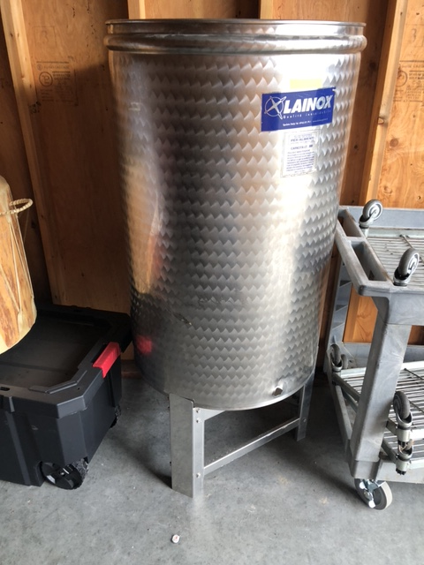

Rolling Stainless Steel Shelves (Great for mobile wine/cider case movements)

* There are 3 @ $25 each OBO

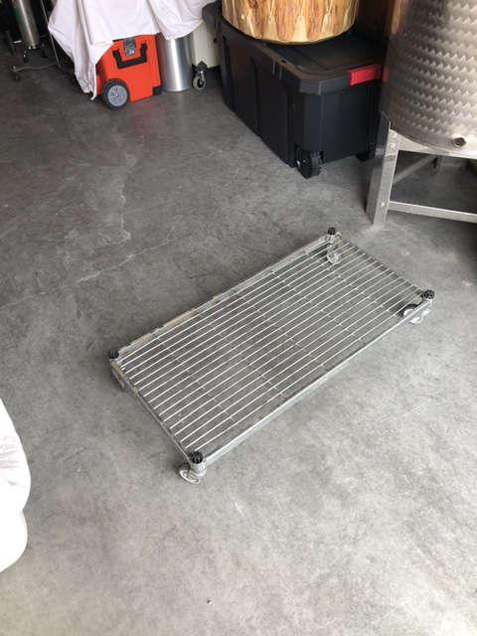

Contact Angie

208-941-5641 (text or call) or email angieshaltry@gmail.com